|  |
| --- |
| Creating Web Application |
| COS10011  Semester 2, 2021 |
|  |
|  |
|  |

|  |  |
| --- | --- |
| Member Name | Member ID |
| Syed Muhammad Hassaan Bin Ghayas | 101231186 |

|  |
| --- |
|  |

Table of Contents

1. Introduction 3

1.1. Scope of the website 3

1.2. Intended audience 3

2. Webpage Design and Structure 3

2.1. Website Layout Mock-ups 3

2.2. Website Structure 4

3. End Product: 6

3.1. Actual User Interface 6

3.1.1. Home Page 6

3.1.2. Product page 8

3.1.3. About 9

3.1.4. Enquiry 10

3.2. Enhancements 11

3.2.1. Hover effect on container: 11

3.2.2. Hover effect on Image: 12

3.2.3. Picture banner blur: 12

3.2.4. Button enhancement: 12

1.a.1. Color Gradient effect on container: 13

3.2.5. Google map address: 13

3.2.6. Enhancement on the form fields: 13

1. Description 15

2. End Product 15

2.1 Enhancements 15

2.1.1 Responsive Hamburger Menu: 15

2.1.2 Image Slideshow: 16

2.1.3 Live Count Down: 17

**Assignment 1**

# Introduction

# Scope of the website

Scope of my website is rental car service. The aim is to provide customer with best cars , 4 categories of Budget, Standard, Luxury and SUV.

# Intended audience

This website directs to audience that are living in Malaysia and are looking for a rental car in standard rates.

# Webpage Design and Structure

# Website Layout Mock-ups

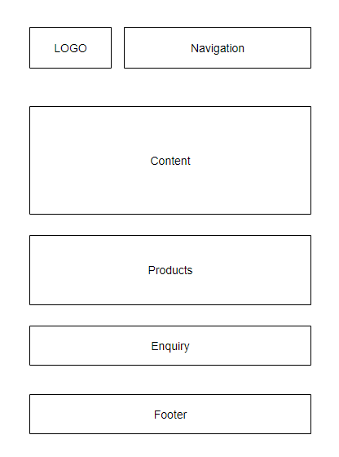

# Website Structure

# 

# End Product:

# Actual User Interface

# Home Page

Logo drop down Navbar

# 

Content on the homepage

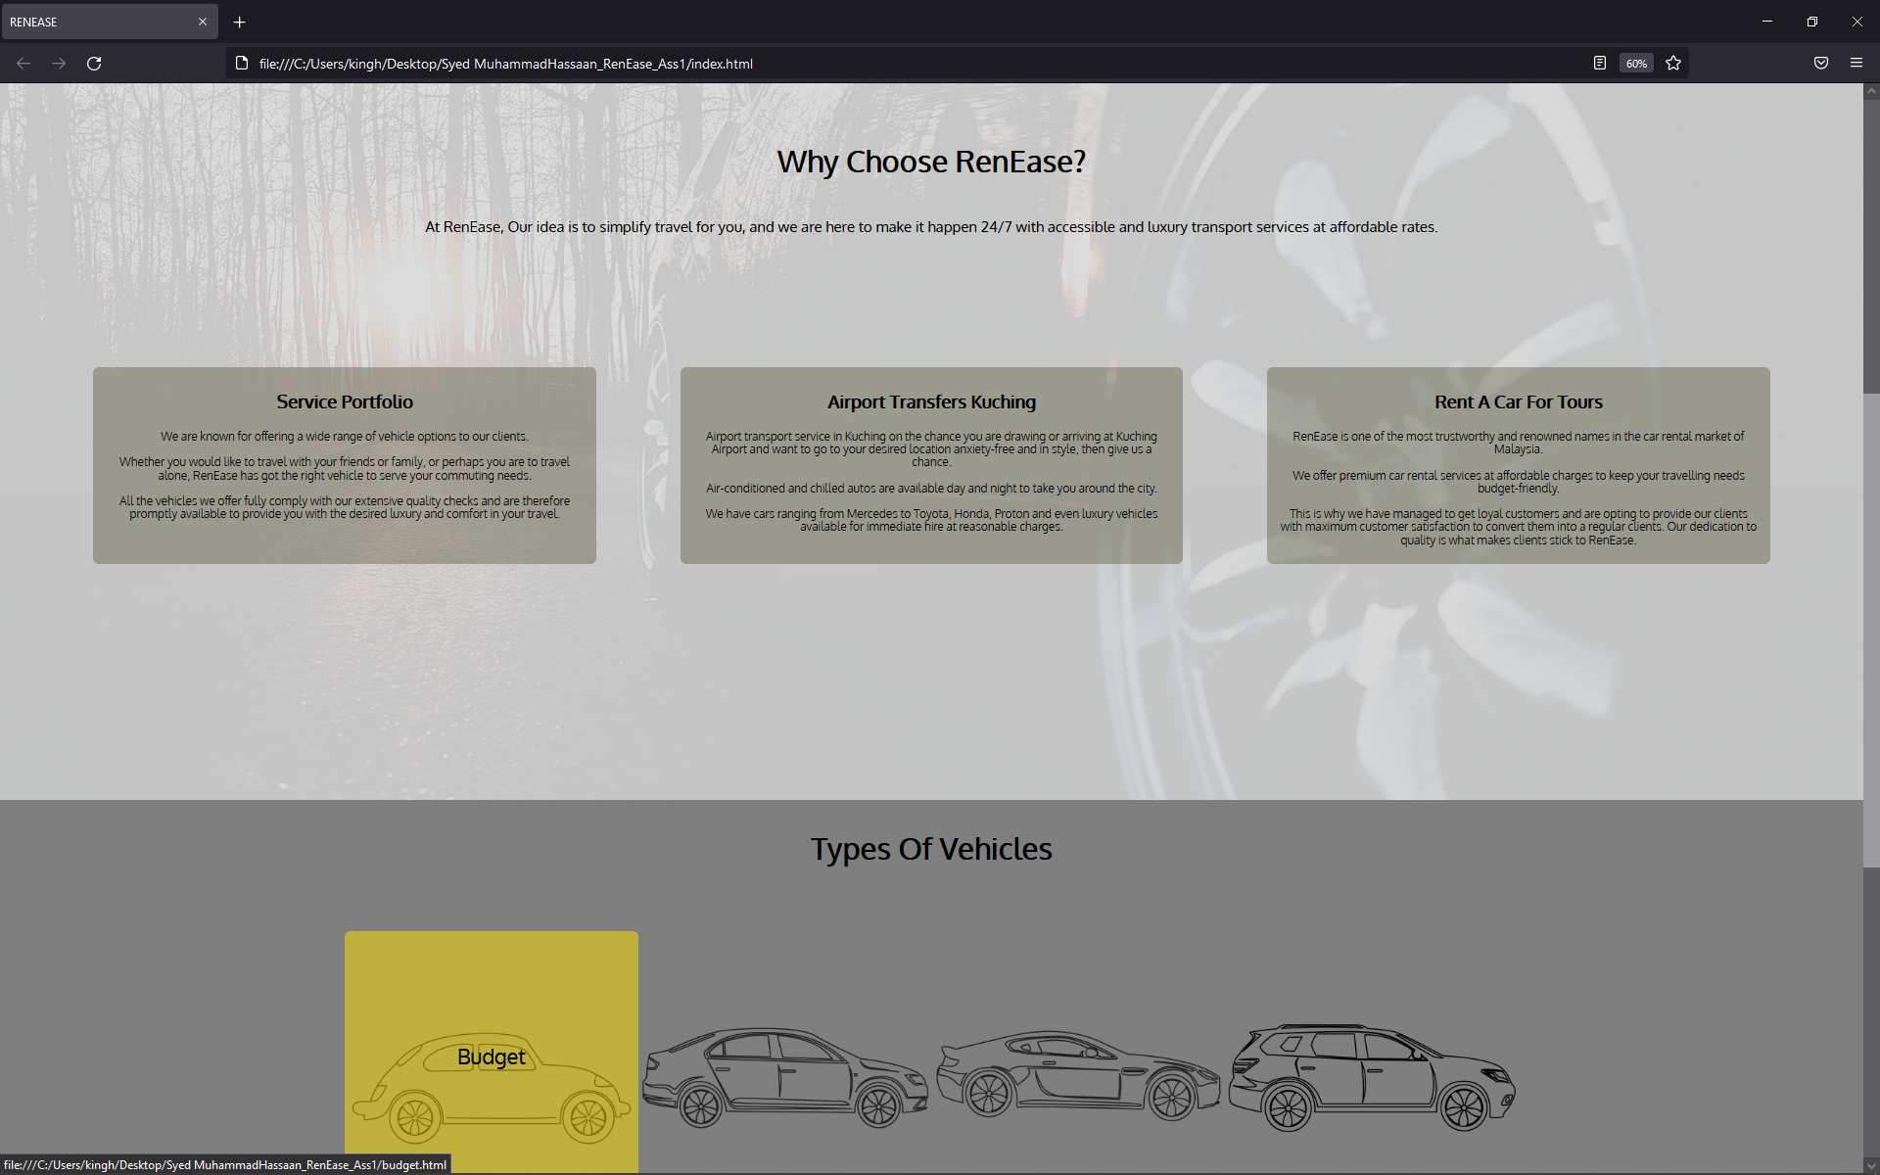

Footer

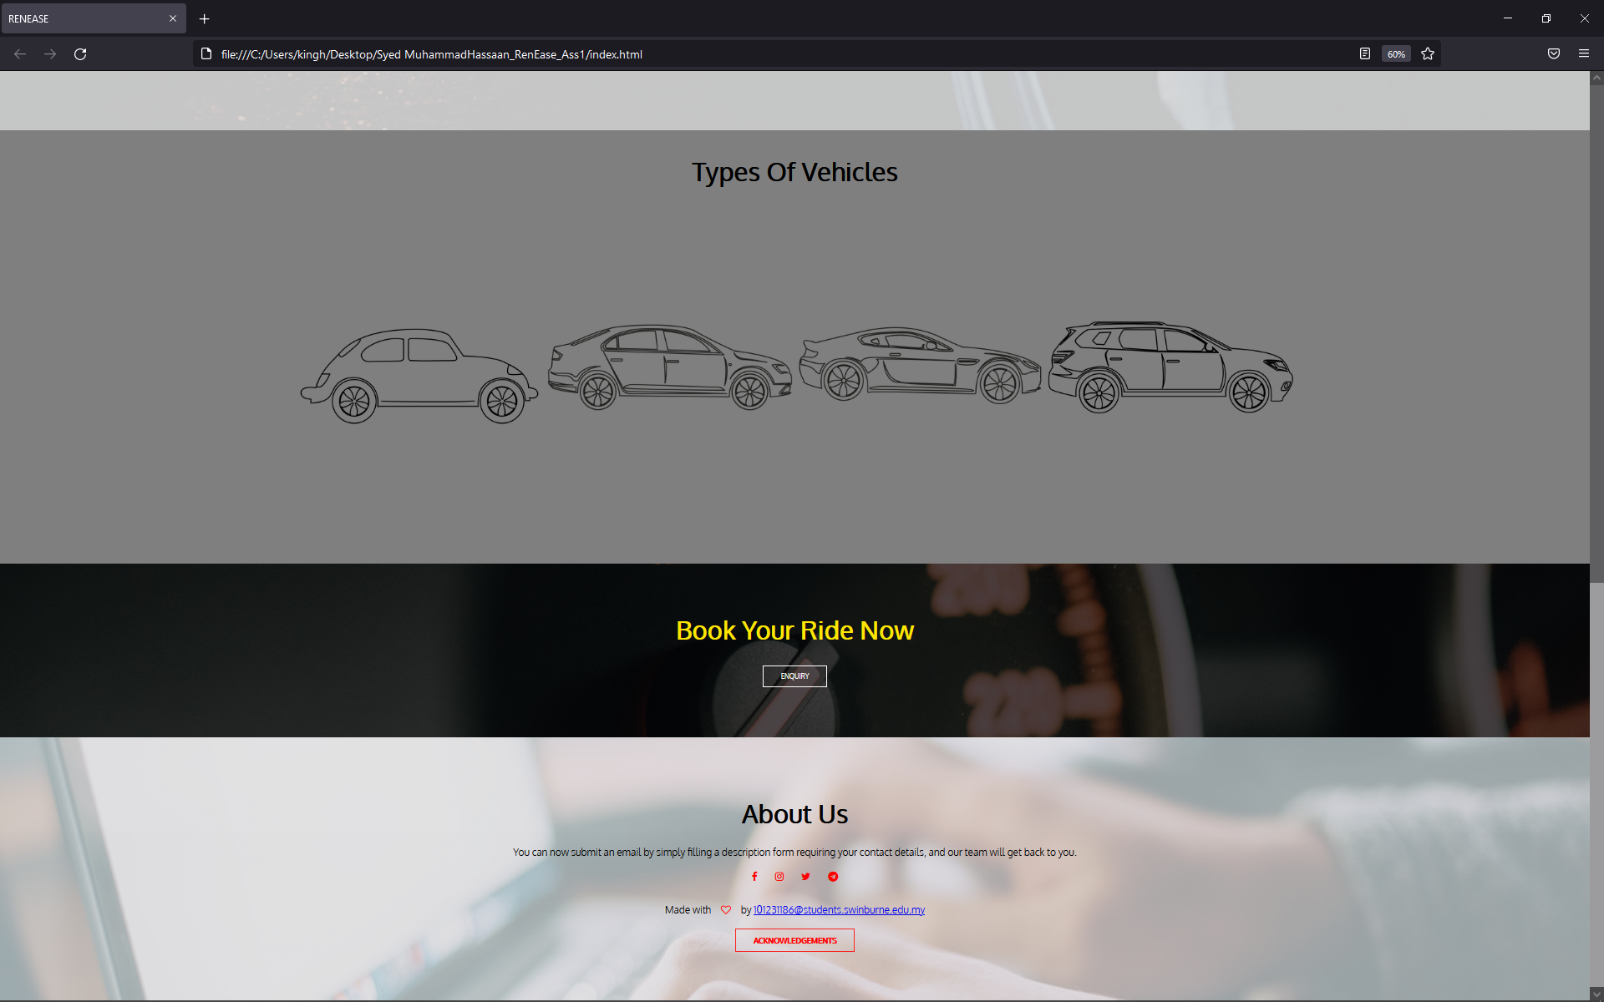

# Product page



# About

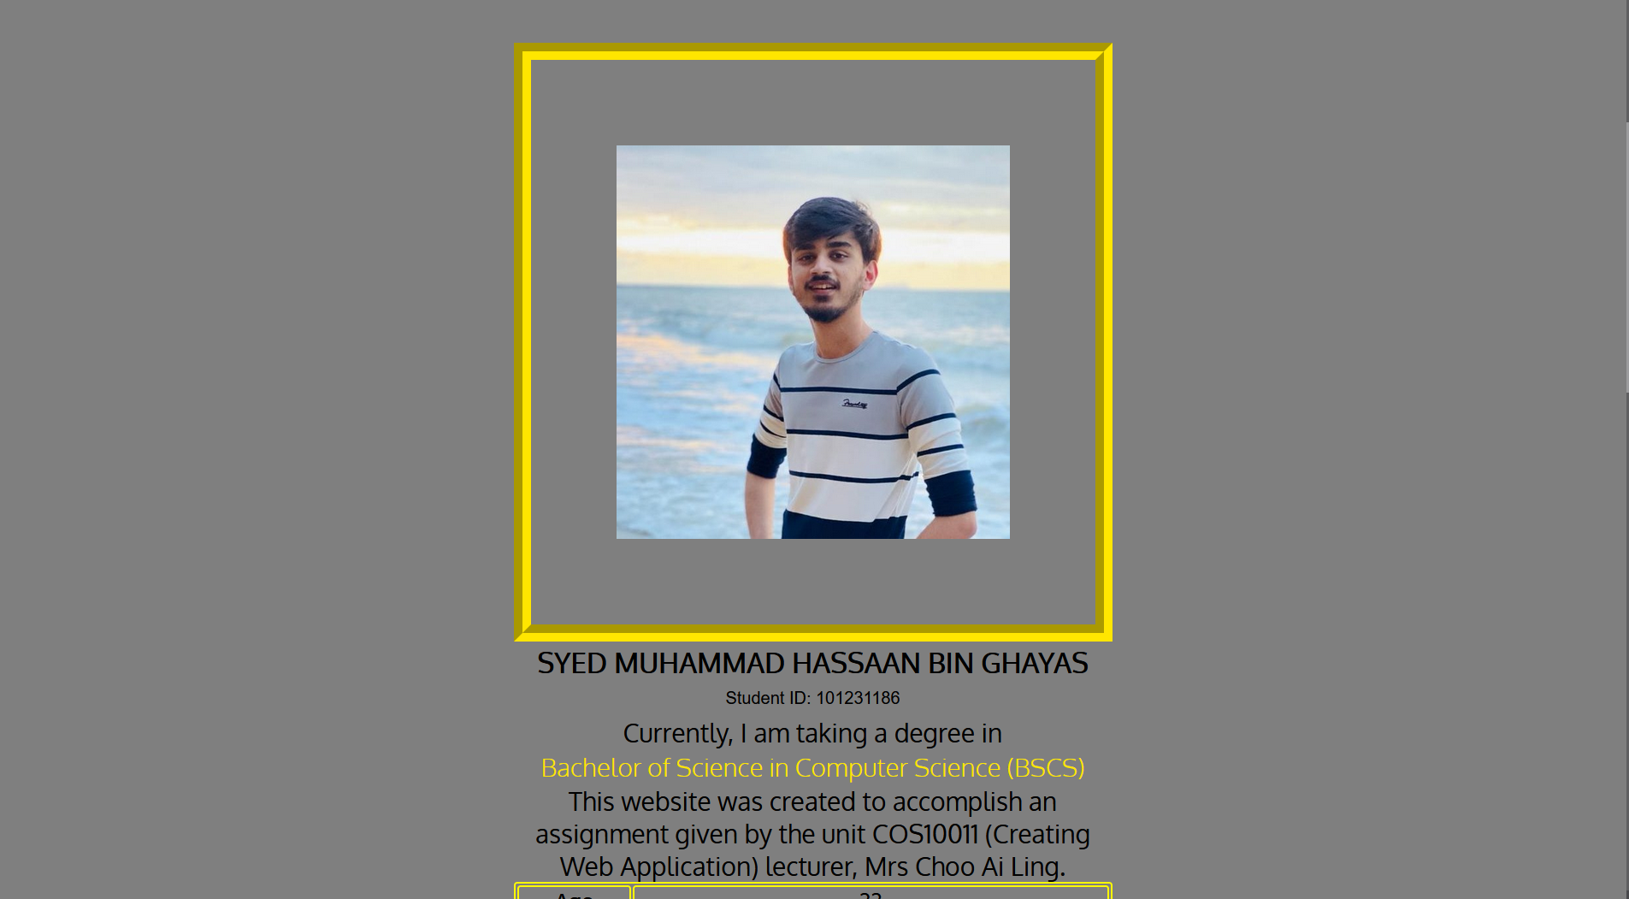

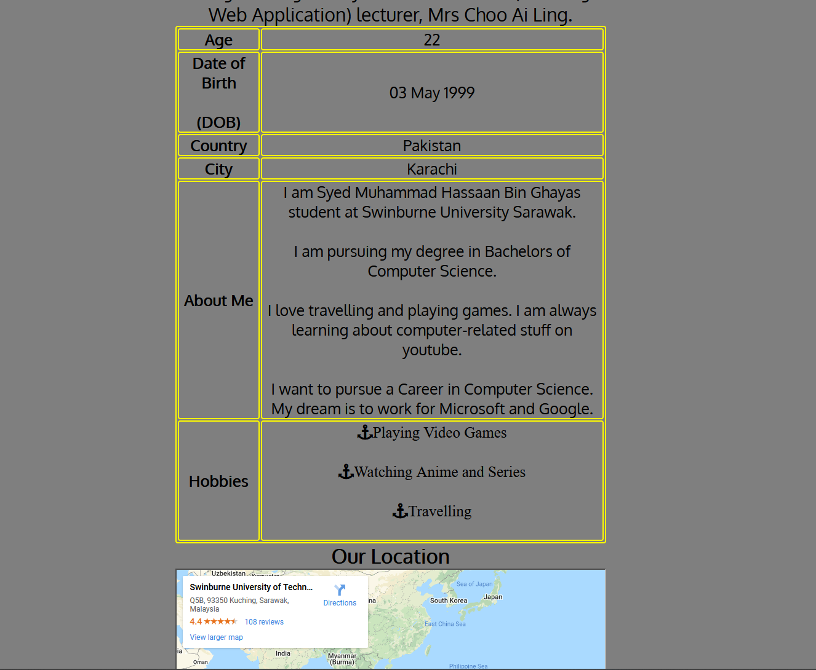

# Enquiry



# Enhancements

I have 7 enhancements in total.

# Hover effect on container:

Hover effect when you take your pointer to the information(container).

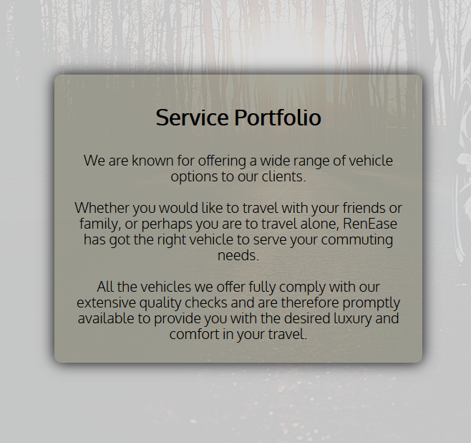

# Hover effect on Image:

When you take your pointer on the image the color changes to yellow and you can click it to move to the page.

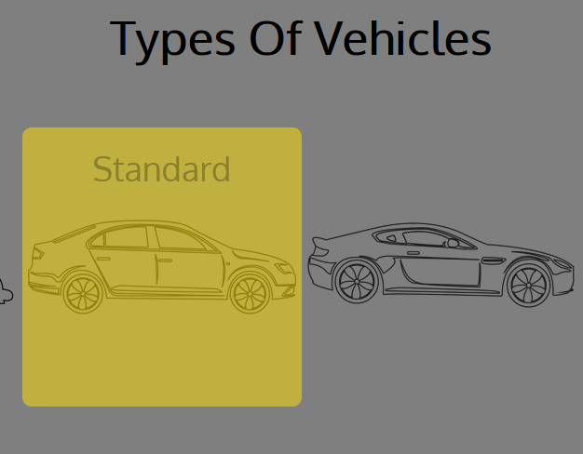

# Picture banner blur:

Picture banner with blur effect to make website look more appealing.

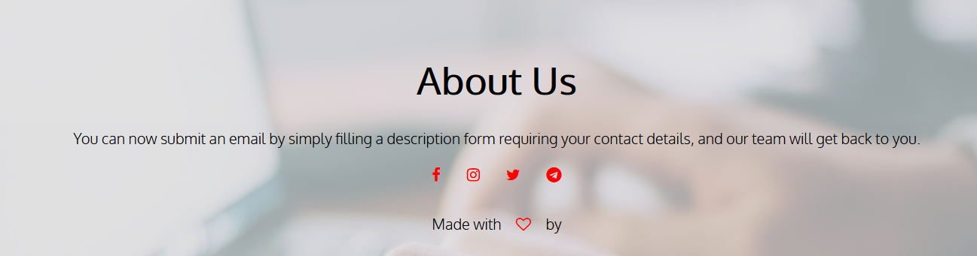

# Button enhancement:

Button when you hover your pointer over it the color changes.



# Color Gradient effect on container:

The gradient color effect for the background with yellow and black color scheme.



# Google map address:

Google map location for the address.

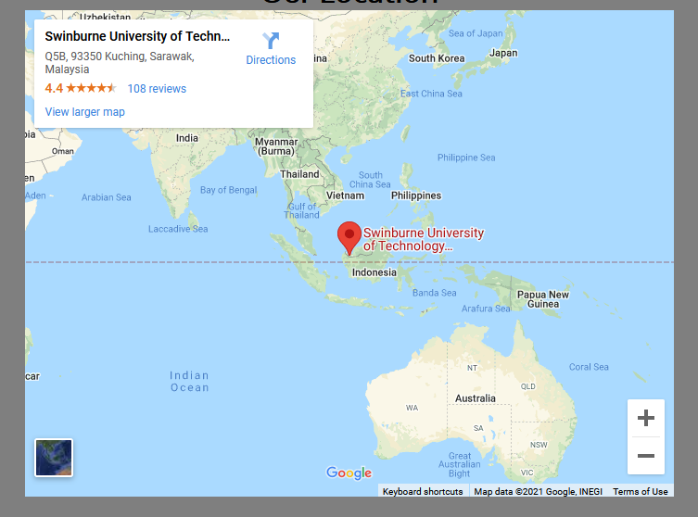

# Enhancement on the form fields:

The border for the form and when you are on specific field the background colour of the field changes to light yellow.

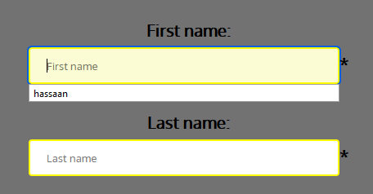

**Assignment 2**

# Description

We used JavaScript on the website to validate the Enquiry form. Then update the form to transfer data between pages and transfer data with-in the same page. These were the basic requirements for the assignment 2.

# End Product

# Enhancements

# Responsive Hamburger Menu:

When website is viewed on mobile device the text and images changes according to the size and the navigation bar changes to hamburger selected icon.

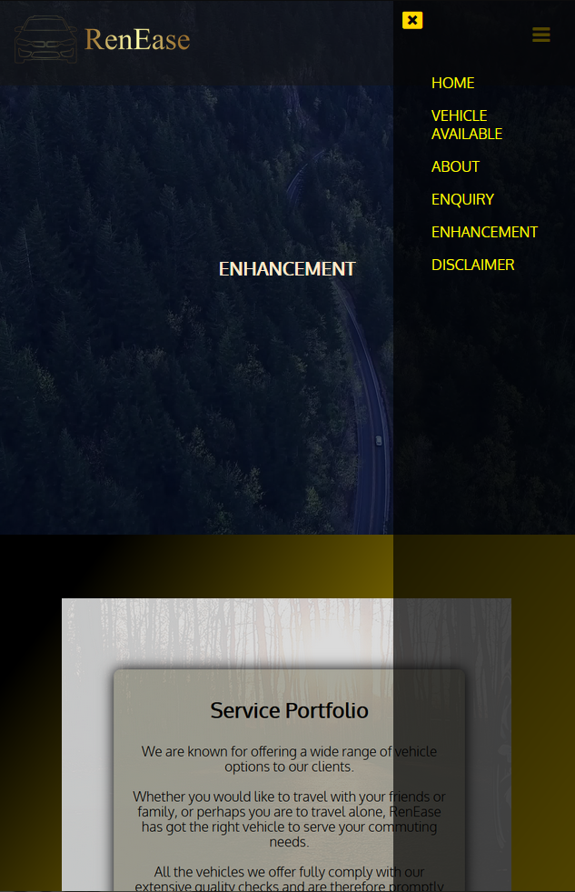

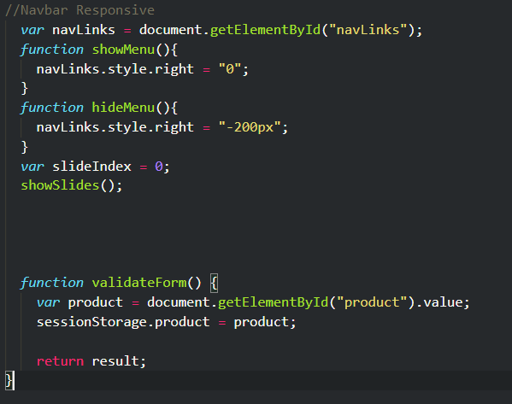

# Image Slideshow:

Image slideshow is enhancement using JavaScript image is changed after every 2 seconds.



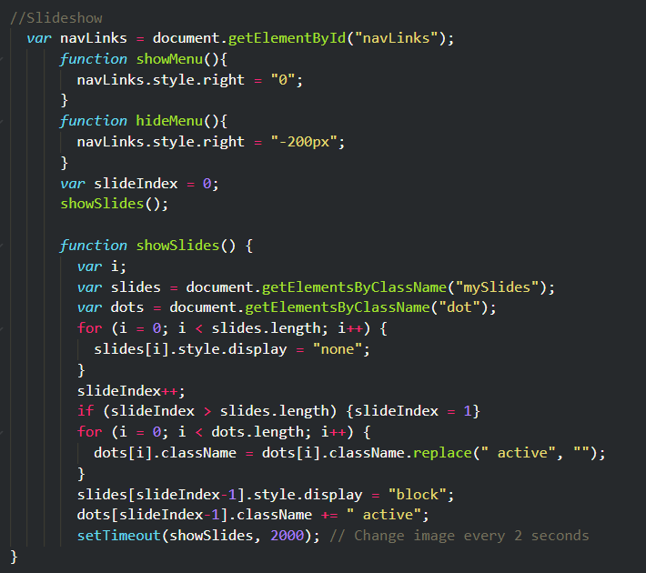

# Live Count Down:

There is a live countdown on the Website for the Lucky draw that will end on New year.



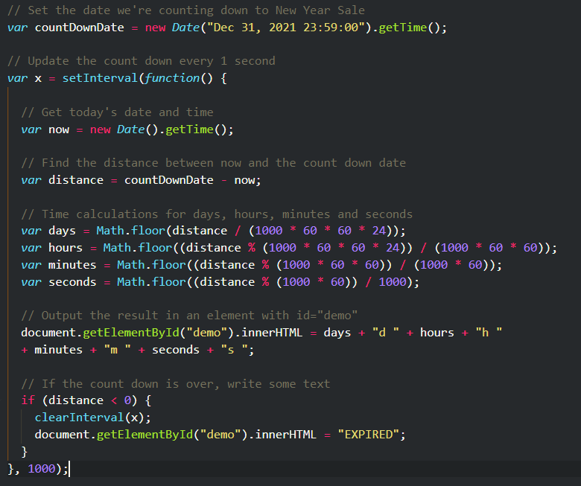

**Assignment 3**

# Description

This project entails converting the entire HTML website to PHP to incorporate the PHP connection to database capability. MySQL is the database utilized in this project. CRUD (Create, Read, Update, and Delete) will be implemented within the system as well as a webpage PHP also made it possible to reuse certain HTML skeletons. I have added a MySQL database for the enquiries page to access all the data quickly and neatly.

This assignment also includes some enhancements. The user Management Module was chosen as the enhancement module to be included.

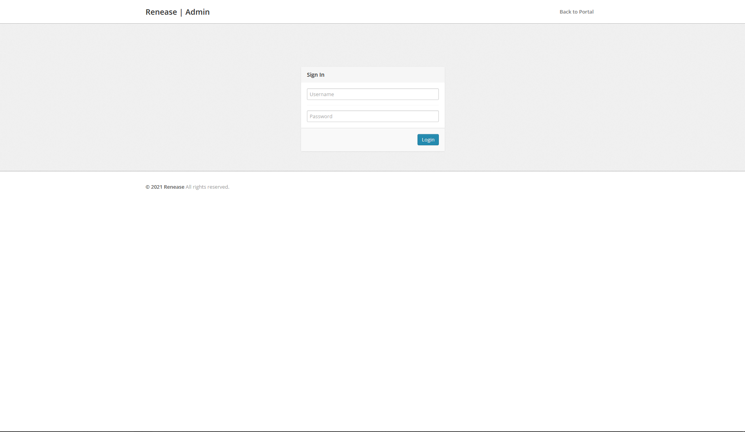

Firstly, we have added a login ID and Password for the admin to access the saved enquiries in the Database.

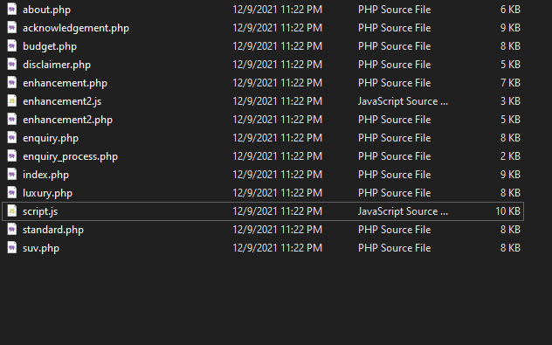

All the Files have been converted to PHP.

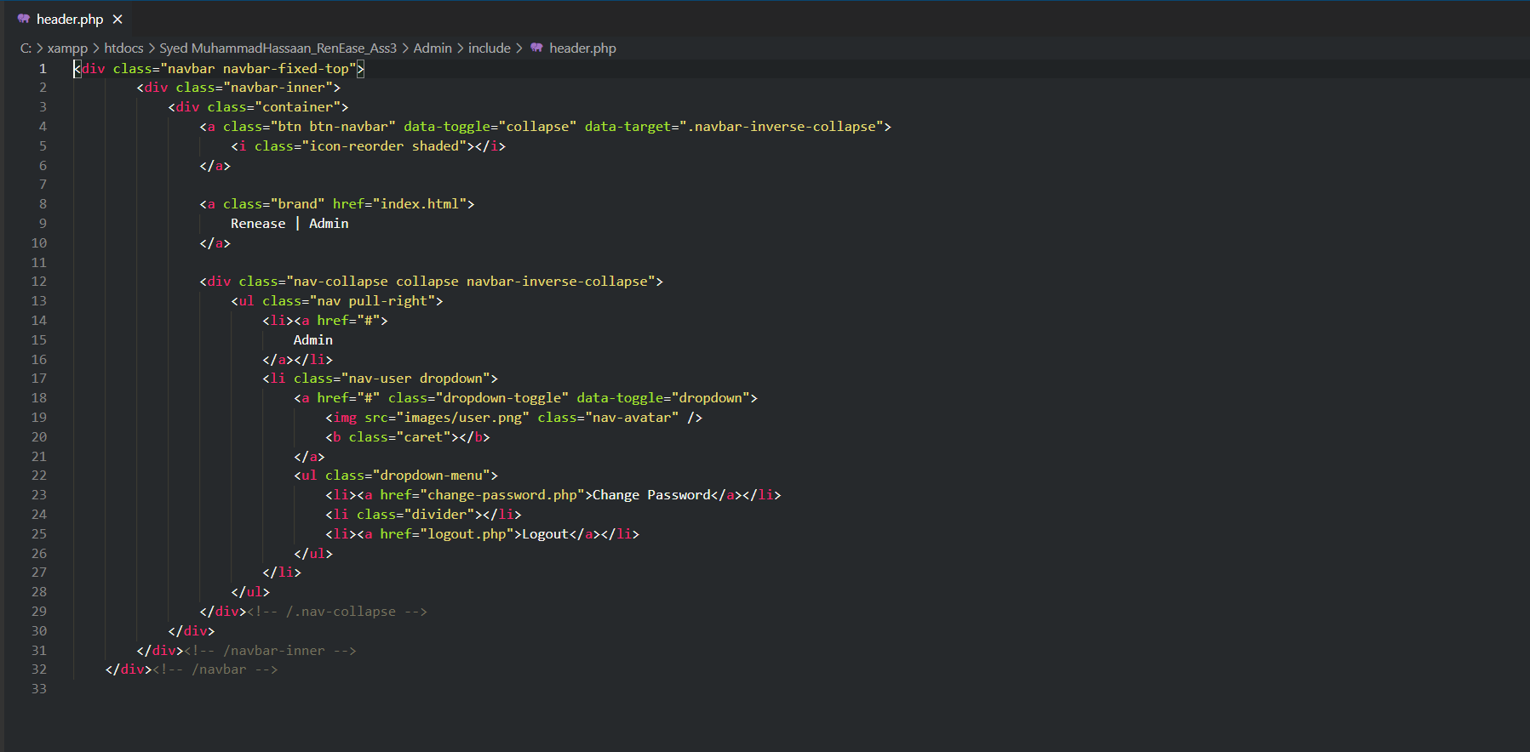

Created a separate file for header.php and footer.php.

# MySQL database structure/schema

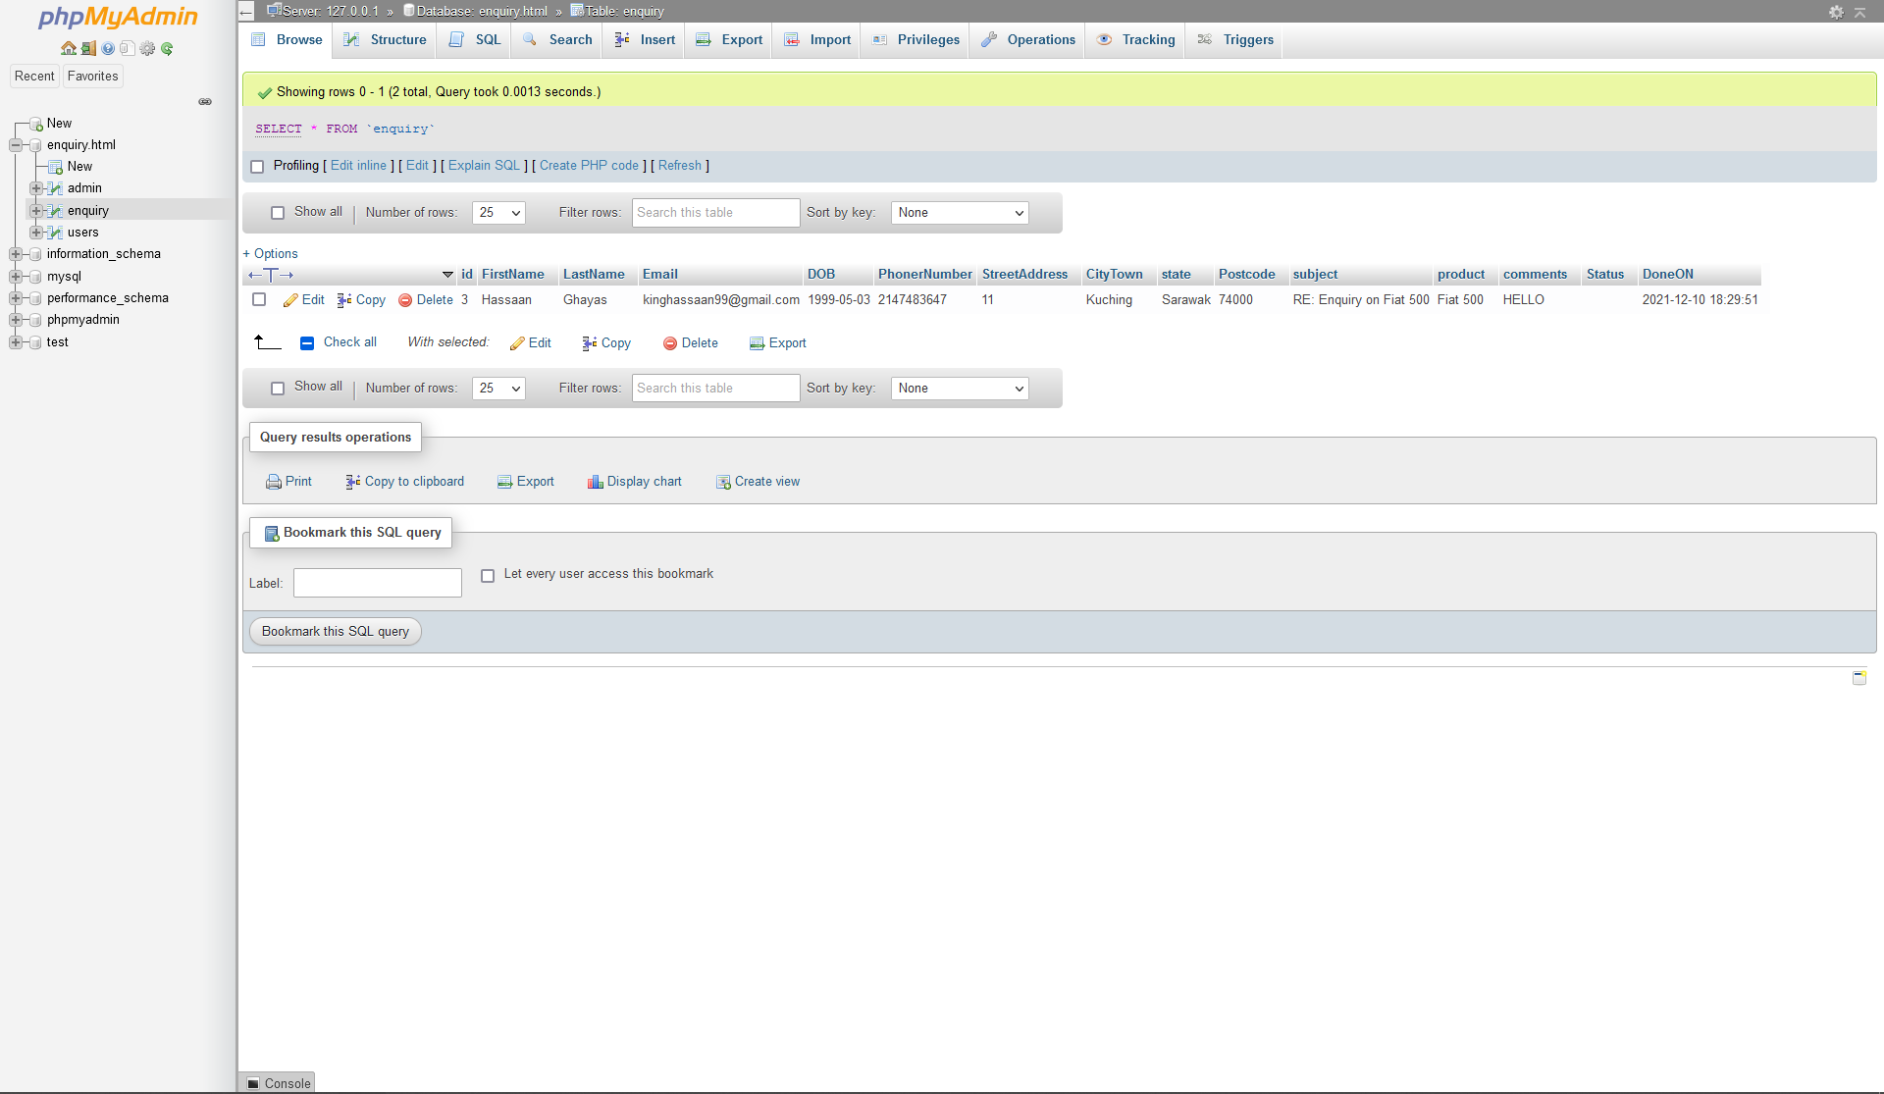

MySQL database can be accessed at enquiry.php

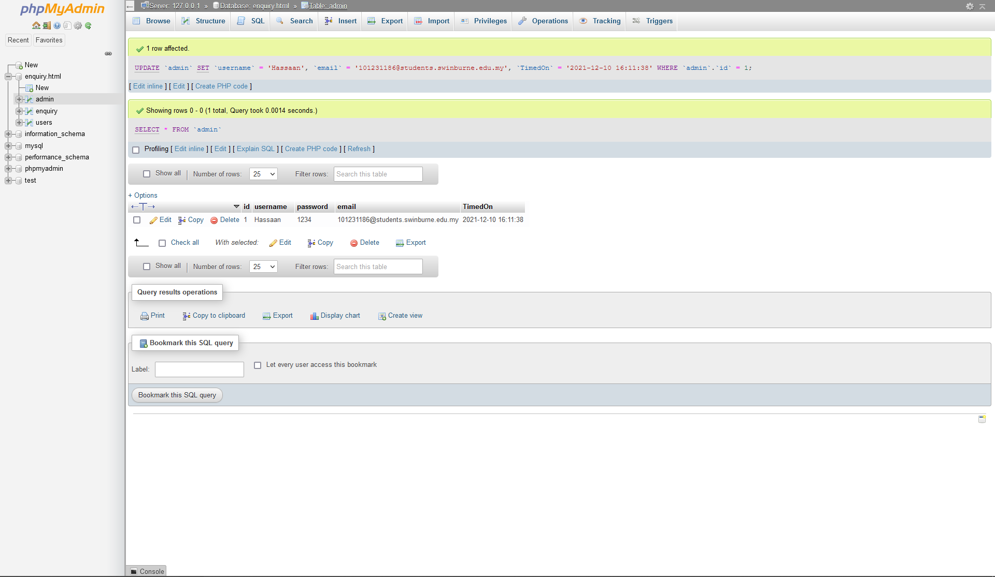

The data can be viewed on the Admin.php page as well.

# End Product (Enhancement):

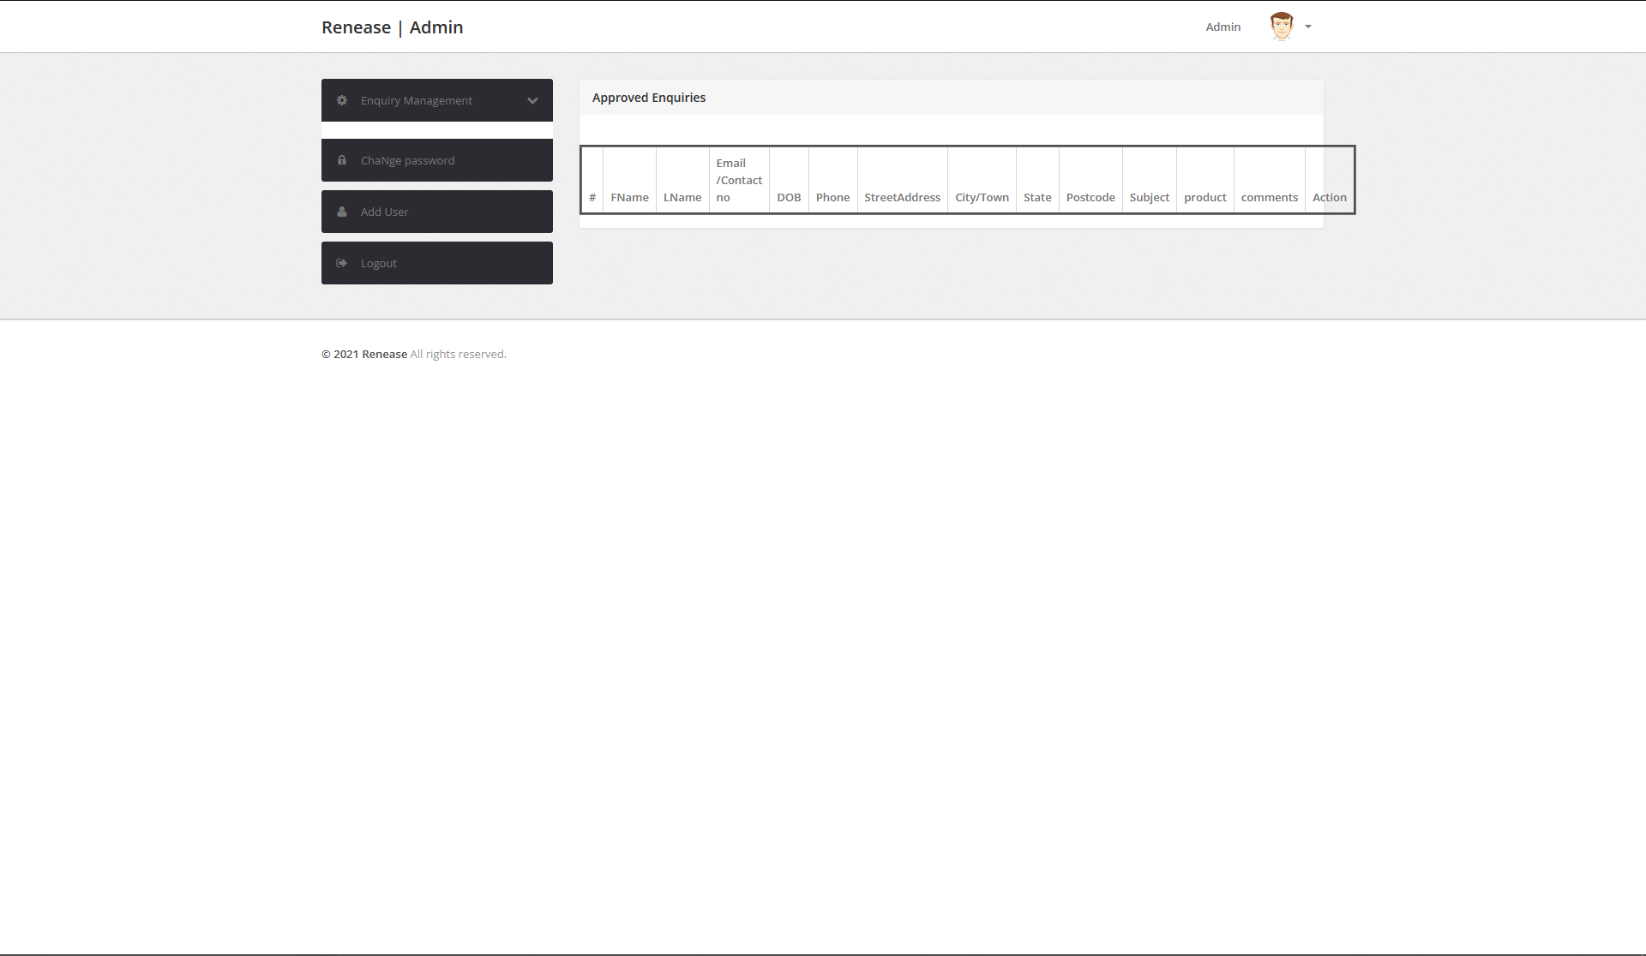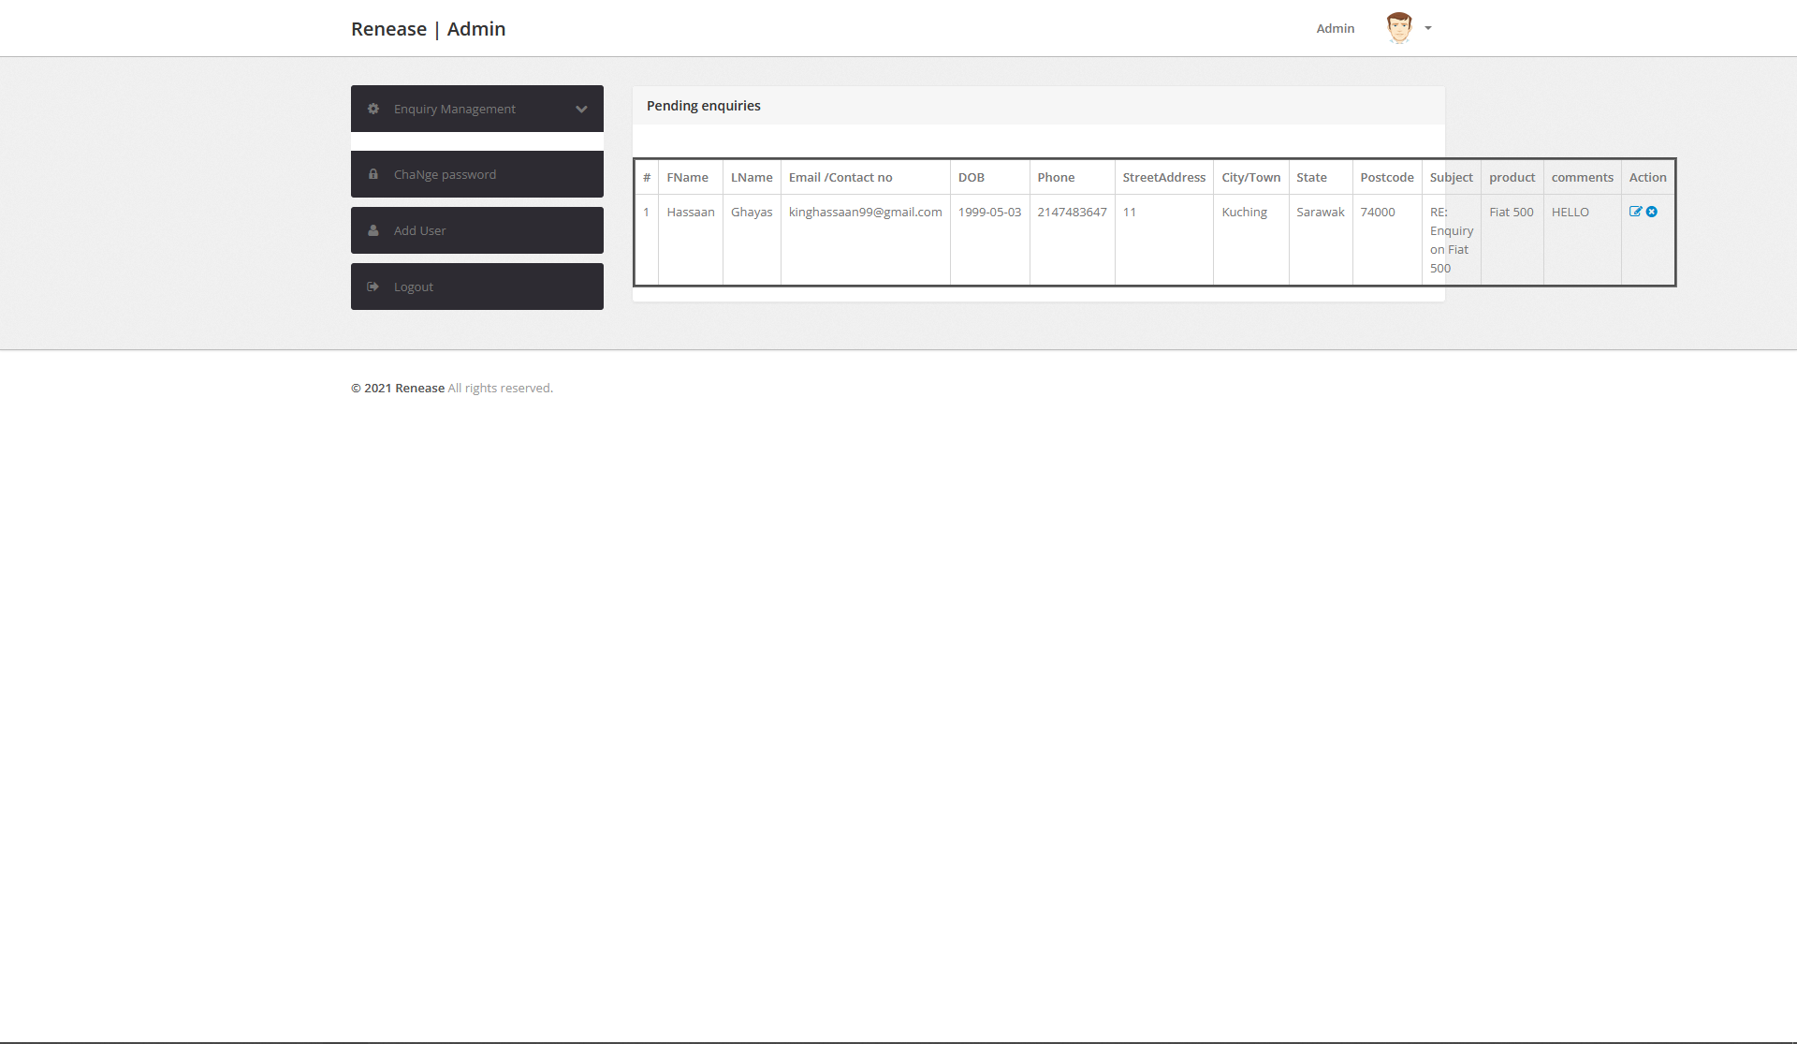

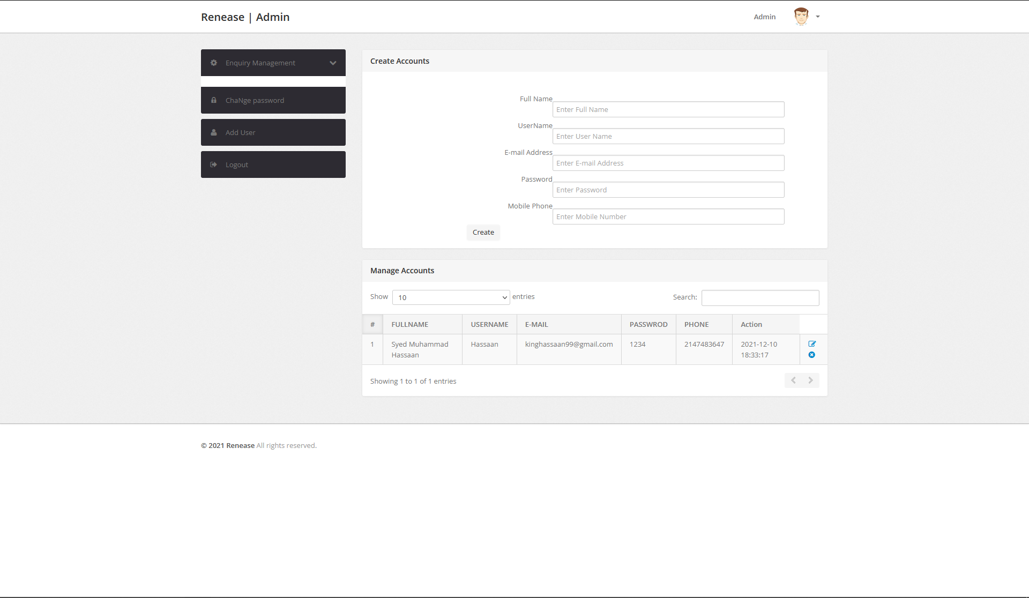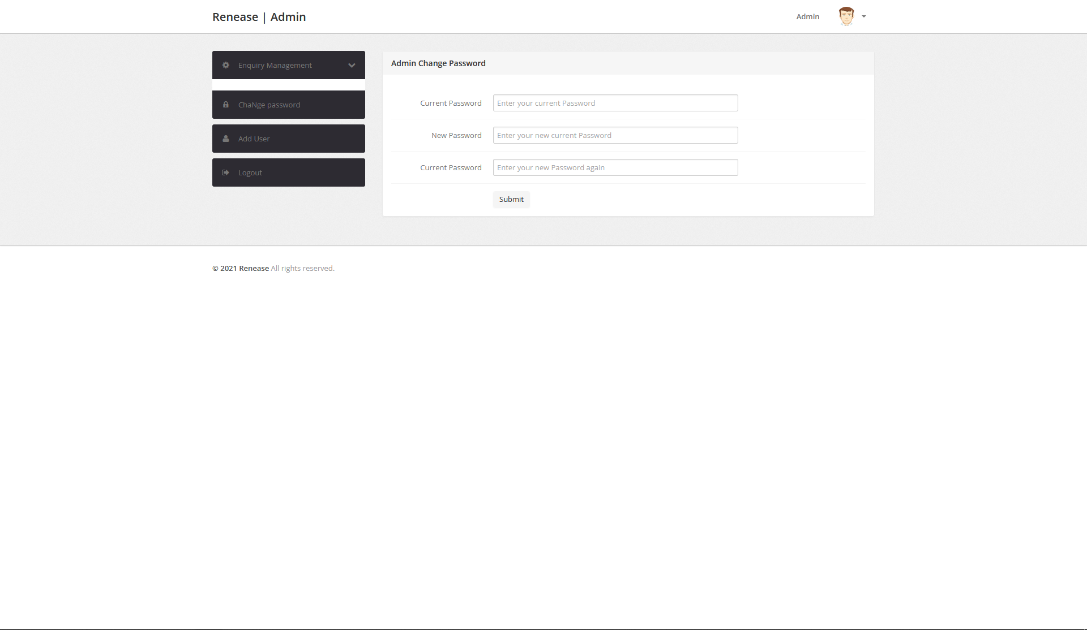

I have added a User Management System where all the users, their logins and passwords are stored. You can add new Users as well as update Information and Delete Users.

**END OF ASSIGNMENT**

**1,2 & 3.**

**THANK YOU**